MCT Assignment For Mean Median Mode

Placement Dataset: Average Salary Prediction for Employees

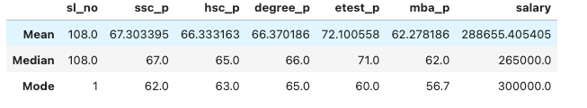

Mean Method:
The mean method considers outliers and calculates the average values. Most employees have the following average percentages: SSC 67.30%, HSC 66.33%, Degree 66.37%, and MBA 62.27%. The average salary is 2 lakh 88 thousand
Median Method:
The median method does not consider outliers and calculates the middle value. Most employees have the following percentages: SSC 67%, HSC 65%, Degree 66%, and MBA 62%.The average salary is 2 lakh 65 thousand.
Mode Method:
The mode method takes the most frequently repeated values among employees. The common percentages are SSC 62%, HSC 63%, Degree 65%, and MBA 56%. The salary is 3 lakh.
This is the placement datasets for employee average salary prediction.

